Introduction
The basic elements of an ILP are 1) reflection on long-term career goals and self-assessment of areas of strength and weakness, 2) goal generation, 3) development of plans/strategies to achieve the goal, 4) assessment of progress on goal, and 5) based on assessment, revising goal/plan or generating a new goal.11 ILPs should be an iterative process, where physicians continuously revise goals or plans considering current learning needs and progress on goals and should be flexible enough to be adapted for use for learners at different levels, as well as to various learning needs and styles. Goals could be long-term or near-term and could focus on improving process (https://www.academicpedsjnl.net/article/S1876-2859(10)00196-8/fulltext)

Process
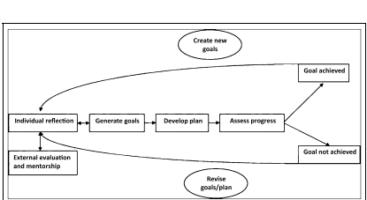
(https://neoreviews.aappublications.org/content/13/4/e207.figures-only)

Initial date –
- Complete ILP questionnaire and set meeting with Program Director
  - Set varying due dates for different element
- After 6 months, evaluate the progress of each initial goal and update each individual goal (mark complete, extend due date, redefine) and set new goals for the next 6 months.
  - Meet with program director and discuss

ILP Form

List your core values (personal or professional)

List your professional goals

List your personal goals

Describe the intersection of your personal/professional goals

Identify (3) individual learning goals to work towards achieving required core competencies.
Identify up to (2) additional personal/professional development goals beyond program requirements.

Choose the core competency(ies) that fit this goal.

Goal (select Core Competency or  “other”) | Process/plans for achieving this goal | How will you know you have accomplished this goal? | Due date for accomplishing goal

