Johns Hopkins Global Cardiac Surgery Initiative

# Mission: Pakistan

As an outreach to share knowledge, Johns Hopkins Cardiac Surgery was recently represented at the First International Congress for Prevention and Rehabilitation of Cardiovascular Diseases and 1st. National Symposium on Heart and Lung Transplantation by Hamza Aziz MD and Fayyaz Hashmi MBBS. It was held on September 21 and 22, 2024 in Lahore, Pakistan.

Presentations: The event was organized by Institute for prevention and Rehabilitation of Cardiovascular Diseases and Pakistan Association of Cardiovascular and Thoracic Surgeons. We were invited to present and share our experience in Innovations in Surgical Treatment of Persistent atrial Fibrillation ( Hamza Aziz) and Minimally Invasive Cardiac Surgery ( Fayyaz Hashmi). We had opportunity to interact with local and international faculty from UK, US, Turkey, India and UAE. Discussions were robust and informative. Audience included cardiologists, cardiac surgeons, residents and fellows along with medical students from various regions of Pakistan.

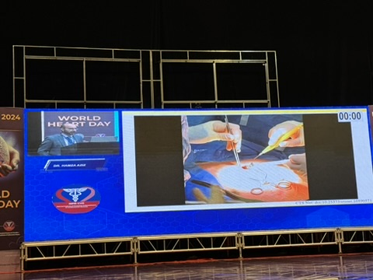

Hamza Aziz MD presenting at the conference.

On-site Mentorship: Pakistan has a very large burden of congenital, rheumatic and ischemic heart diseases afflicting millions. A vast majority of the patients are young, in the prime of their earning potentials supporting large families which makes it imperative to figure out surgical solutions which are durable, reproducible and return these patients back to work as early as possible. This provides us opportunity to share our experiences. Following the congress, Hamza and I, both took part in workshops arranged at Punjab Institute of Cardiology, RA Institute of Cardiology at Social Security Hospital and Cardiac Surgery department at Sheikh Zayed Hospital, all in Lahore. We performed Minimally Invasive Direct Coronary Artery Bypass(MIDCAB), Off Pump Coronary Artery Bypass(OPCAB), minimally invasive Mitral valve repair and replacements, minimally invasive Aortic Valve Replacement and minimally invasive repair of Atrial Septal Defect. All cases were done with local cardiac surgeons and trainees with excellent results. In revascularization cases, the emphasis was on multi-arterial grafts utilizing bilateral internal thoracic arteries and radial arteries.

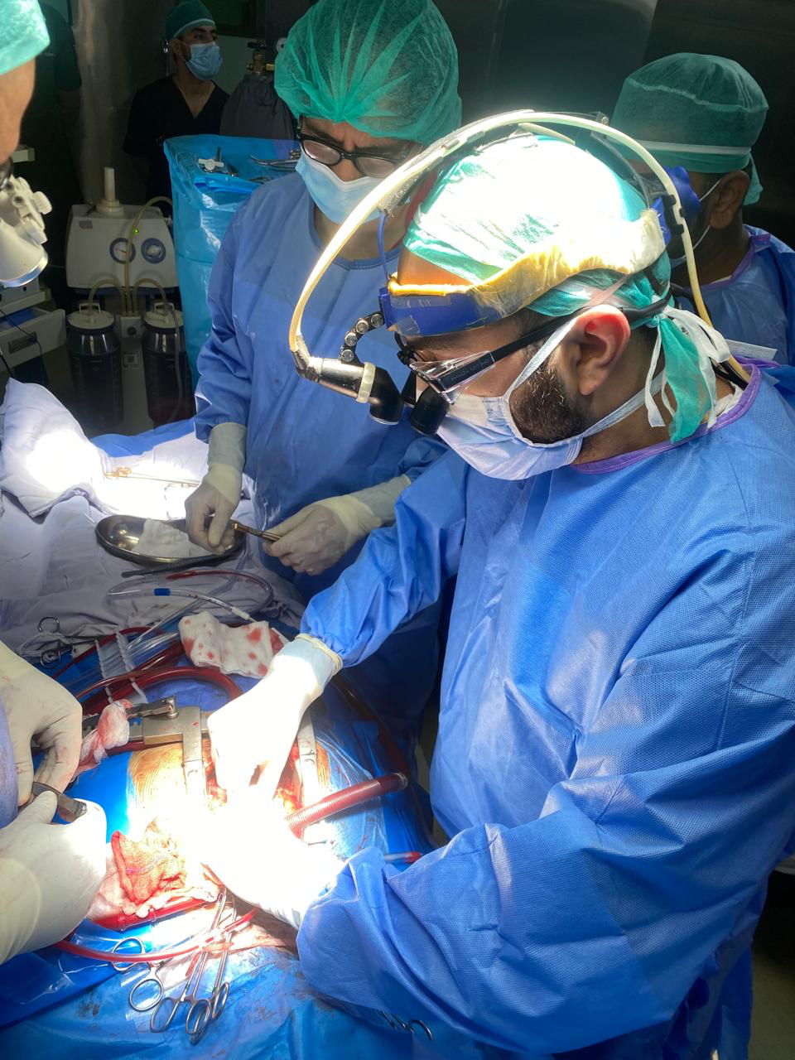

Hamza Aziz MD performing coronary artery bypass surgery at RA Institute of Cardiology, Lahore, Pakistan.

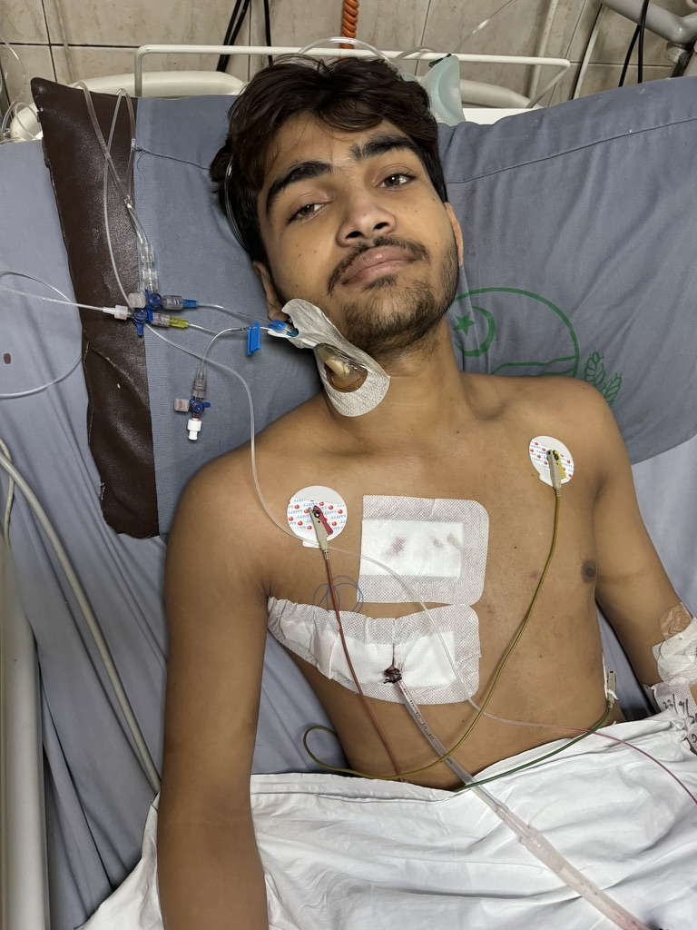

1st day post op patient minimally invasive aortic valve replacement at Punjab Institute of Cardiology, Lahore, Pakistan. ( photo taken with patient’s permission).

Educational Activities: As part of continued engagement for education in the future as well as sustainability of our outreach, meetings were held with president of Pakistan Association of Cardiovascular and Thoracic Surgeons and Dean of Cardiac Surgery at Pakistan College of Physicians and Surgeons, governing body for all post graduate medical education in the country, They are keen and excited about the prospects of cooperative efforts to improve quality of cardiac surgical care in Pakistan. Johns Hopkins Cardiac Surgery can offer remote learning through internet by sharing links with training programs to case conferences, didactic lectures, grand rounds as well as mini observer ships to mid-career cardiac and thoracic surgeons. The observer ships will be underwritten by a third party, a nonprofit, set up by US based cardiothoracic surgeons of Pakistani origin. Since Pakistani cardiac surgery programs perform a very large number of valve surgeries, rotations by JH cardiac surgery trainees and on-site mentorship by JH faculty was also discussed with very positive response. We are working on MOUs to be signed by the principals involved. Dr. Jim Gammie, co-director Johns Hopkins Heart and Vascular Institute has offered full support for the educational and mentor-ship efforts.

Disease Prevention: Pakistan has one of the highest rheumatic heart diseases (RHD) burdens in the world. An estimated 1.65 million patients are afflicted with valvular lesions, disease peeking at 20-29 years of age. The rate of rheumatic fever has declined slightly because of easier access to antibiotics; however, it is still far more prevalent than most other low- and middle-income countries. Meetings were held with chairman and vice chancellor of Children’s Hospital, Lahore and Children Health Sciences University, head of Child Life Foundation and Pakistan Children Heart Foundation(PCHF) to devise a path forward to diagnose streptococcus A infections, treat early to prevent development of rheumatic fever and then have follow up by pediatricians and pediatric cardiologist. Screening for strep throat infections will be performed at Child Life Foundation which has 300+ outreach clinics and runs 30 pediatric emergency departments in large public hospitals throughout the country. Supply of Rapid strep antigen test kits were discussed. Surveillance echocardiography would be done where warranted in collaboration with PCHF. A pilot project will be started in next few months. Majority of patients with symptomatic RHD in their twenties and beyond would need surgical treatment, a huge burden which needs to be addressed but will be incorporated in our discussions with local public sector surgery programs in future.